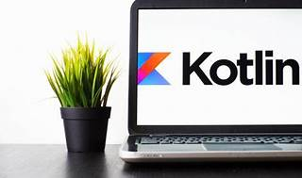

Explore

**Kotlin** is a statically typed, general-purpose programming language developed by **JetBrains**. It is designed to interoperate fully with **Java** and is ideal for **Android app development**. [Additionally, it works on various platforms, including **iOS, macOS, Windows, and Linux**1](https://kotlinlang.org/)[2](https://www.geeksforgeeks.org/kotlin-programming-language/)[3](https://en.wikipedia.org/wiki/Kotlin_%28programming_language%29).

Here are **five free reference links** where you can learn more about Kotlin:

1. [**Kotlin Programming Language**](https://kotlinlang.org/): The official website provides comprehensive documentation, tutorials, and examples.
2. [**GeeksforGeeks Kotlin Tutorial**](https://www.geeksforgeeks.org/kotlin-programming-language/): GeeksforGeeks offers detailed articles and practical examples for learning Kotlin.
3. [**Wikipedia - Kotlin (programming language)**](https://en.wikipedia.org/wiki/Kotlin_%28programming_language%29): Explore the Wikipedia page for an overview of Kotlin’s features and history.
4. **Kotlin Playground**: Experiment with Kotlin code snippets in an interactive online environment.
5. [**Kotlin Foundation**](https://kotlinlang.org/): Engage with the Kotlin community, access resources, and get support from fellow developers.

Happy learning! 🚀